Contents

Project build: 3

Chaincode setup: 3

Setting up the Hyperledger Fabric Test network 4

Create Channel : mychannel 4

Package: 4

Install: 5

Approve: 6

Commit: 6

Invoke 7

Initial method test: 7

Created patient 7

Method name : createMedicalRecord 7

Arguments : String patientId, String name, String diagnosis,String treatment, String dateofVisit 7

Command: 7

Result: 7

View patient record 8

Method name: viewMedicalRecord 8

Arguments: String patientId 8

Command: 8

Result 8

Not exist patient 8

Same patient creation 8

Update record 8

Method name: updateMedicalRecord 8

Arguments : String patientId, String diagnosis, String treatment,String dateOfVisit 8

Command: 8

Result: 9

Query updated details: 9

Create reports: 9

Method name: addTestReport 9

Arguments: String patientId, String reportId, String reportName, String description, String 9

Command: 9

Result: 9

Query reports: 10

Create same report: 10

Create another report: 10

Query test report: 10

Update test report 11

Method name: updateTestReport 11

Argument: String patientId, String reportId, String reportName, String description, String reportDate, String resportIssuer 11

Command: 11

Result: 11

Add medicine: 12

Method name: addMedicine 12

Arguments: String patientId, String medicineName, String medicineExpiry, String medicineTakenDate 12

Command: 12

Result: 12

Add more medicine: 12

Query medicine taken on particular day: 12

Method name: viewMedicineTakenOnParticularDate 12

Arguments: String patientId, String date 12

Command: 12

Result: 13

Query medicine taken between days 13

Method name: viewMedicineTakenOnStartAndEndDate 13

Arguments: String patientId, String startDate, String endDate 13

Command: 13

Result: 13

Get all medicine: 13

Method name: getAllMedicine 13

Arguments: String patientId 13

Command: 13

Result: 14

# Project build:

**./gradlew installDist**

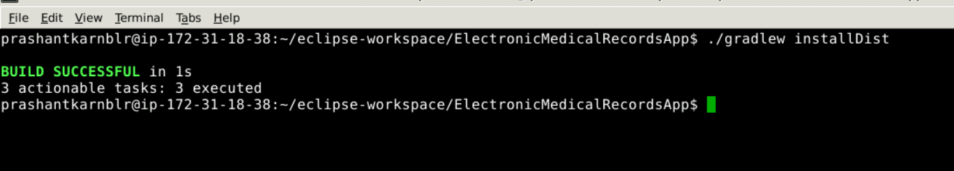

# Chaincode setup:

Paste Project inside **chaincode** folder of fabric-samples



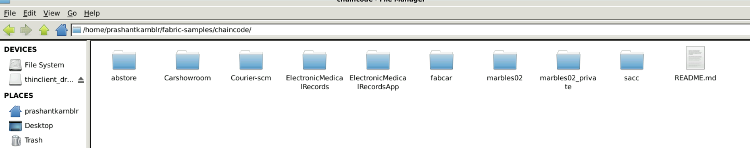



Go inside <project>/lib folder and copy all four files and paste into inside <project>

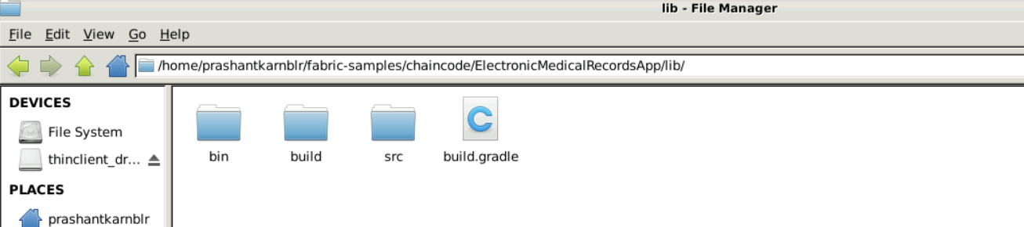

Change lib folder name to <project> name.

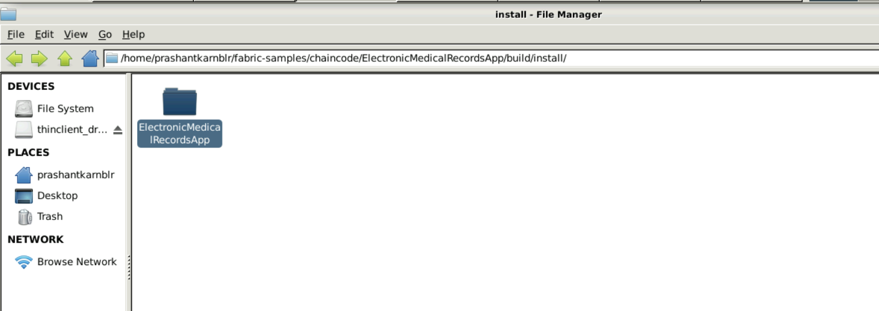

Change lib-1.0.jar to <project>-1.0.jar

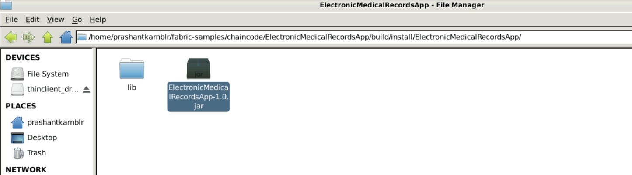

# Setting up the Hyperledger Fabric Test network

1. Navigate to fabric-samples/test-networks:

***cd fabric-samples/test-network***

1. Stop the previously running test network by running the following command:

***sudo ./network.sh down***

1. Remove the unused docker images by running the following command:

***sudo docker system prune***

1. Start the test network by executing the following command:

***sudo ./network.sh up -ca -s couchdb***

# Create Channel : mychannel

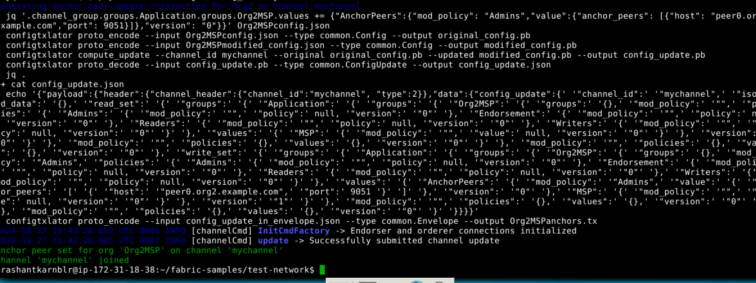

# Package:

*nano lifecycle_setup_org1.sh*

**Add this script:**

***#!/bin/sh***

***export PATH=${PWD}/../bin:${PWD}:$PATH***

***export FABRIC_CFG_PATH=$PWD/../config/***

***export CORE_PEER_TLS_ENABLED=true***

***export CORE_PEER_LOCALMSPID="Org1MSP"***

***export CORE_PEER_TLS_ROOTCERT_FILE=${PWD}/organizations/peerOrganizations/org1.example.com/peers/peer0.org1.example.com/tls/ca.crt***

***export CORE_PEER_MSPCONFIGPATH=${PWD}/organizations/peerOrganizations/org1.example.com/users/Admin@org1.example.com/msp***

***export CORE_PEER_ADDRESS=localhost:7051***

***export ORDERER_CA=${PWD}/organizations/ordererOrganizations/example.com/orderers/orderer.example.com/msp/tlscacerts/tlsca.example.com-cert.pem***

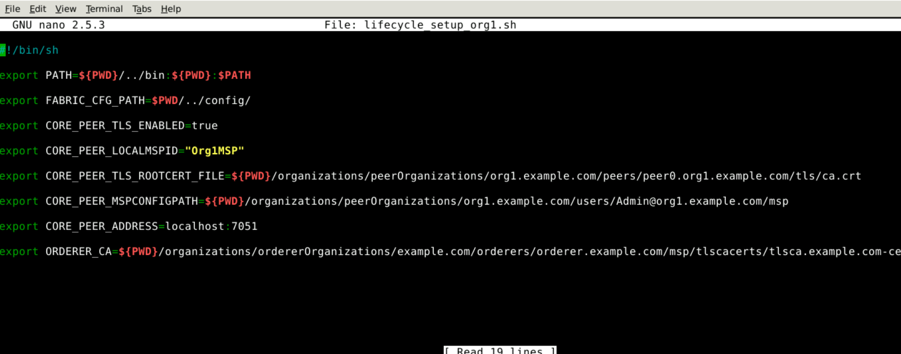

Ctrl + X 🡪press Y

source ./lifecycle_setup_org1.sh

peer lifecycle chaincode package ElectronicMedicalRecordsApp.tar.gz --path ../chaincode/ElectronicMedicalRecordsApp/build/install/ElectronicMedicalRecordsApp --lang java --label ElectronicMedicalRecordsApp_1

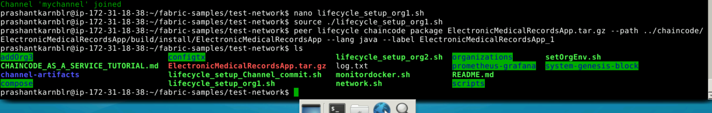

# Install:

For organization 1:

peer lifecycle chaincode install ElectronicMedicalRecordsApp.tar.gz --peerAddresses localhost:7051 --tlsRootCertFiles $CORE_PEER_TLS_ROOTCERT_FILE

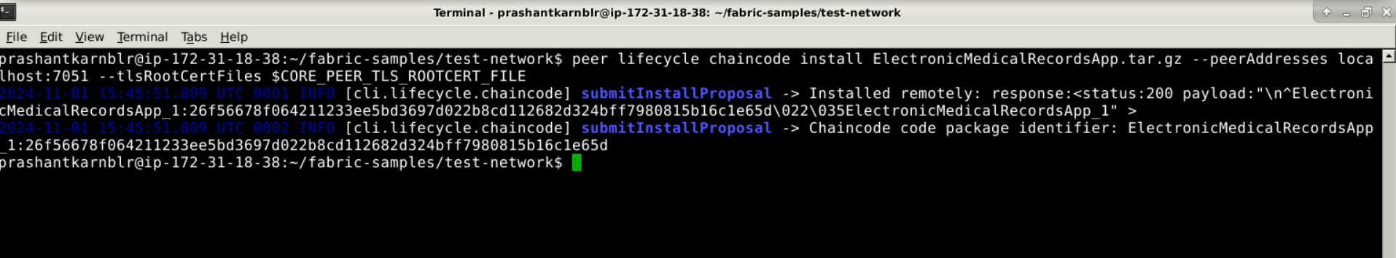

For org2:

peer lifecycle chaincode install ElectronicMedicalRecordsApp.tar.gz --peerAddresses localhost:9051 --tlsRootCertFiles $CORE_PEER_TLS_ROOTCERT_FILE

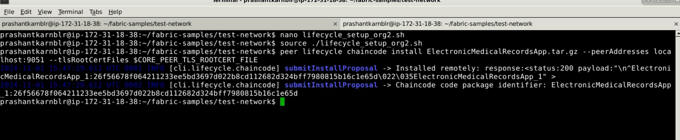

# Approve:

peer lifecycle chaincode approveformyorg -o localhost:7050 --ordererTLSHostnameOverride orderer.example.com --tls --cafile $ORDERER_CA -C mychannel --name ElectronicMedicalRecordsApp --version 1.0 --init-required --package-id ElectronicMedicalRecordsApp_1:26f56678f064211233ee5bd3697d022b8cd112682d324bff7980815b16c1e65d --sequence 1

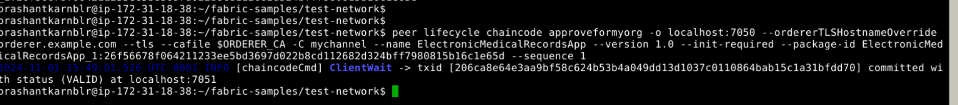

For org2:

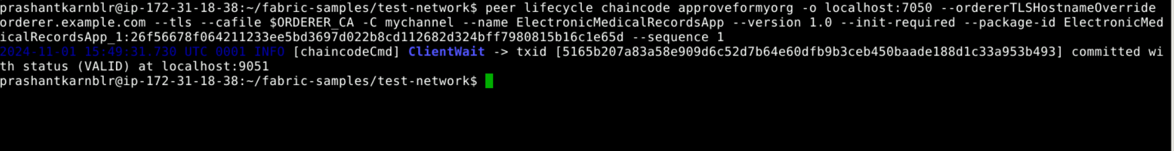

# Commit:

*nano lifecycle_setup_Channel_commit.sh*

*source ./lifecycle_setup_Channel_commit.sh*

peer lifecycle chaincode commit -o localhost:7050 --ordererTLSHostnameOverride orderer.example.com --tls $CORE_PEER_TLS_ENABLED --cafile $ORDERER_CA -C mychannel --name ElectronicMedicalRecordsApp --peerAddresses localhost:7051 --tlsRootCertFiles $CORE_PEER_TLS_ROOTCERT_FILE_ORG1 --peerAddresses localhost:9051 --tlsRootCertFiles $CORE_PEER_TLS_ROOTCERT_FILE_ORG2 --version 1.0 --sequence 1 --init-required

For org1:

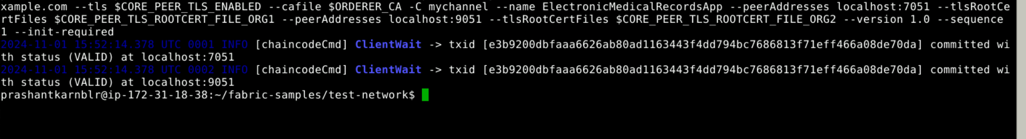

# Invoke

## Initial method test:

peer chaincode invoke -o localhost:7050 --ordererTLSHostnameOverride orderer.example.com --tls $CORE_PEER_TLS_ENABLED --cafile $ORDERER_CA -C mychannel -n ElectronicMedicalRecordsApp --peerAddresses localhost:7051 --tlsRootCertFiles $CORE_PEER_TLS_ROOTCERT_FILE_ORG1 --peerAddresses localhost:9051 --tlsRootCertFiles $CORE_PEER_TLS_ROOTCERT_FILE_ORG2 --isInit -c '{"Args":[]}'

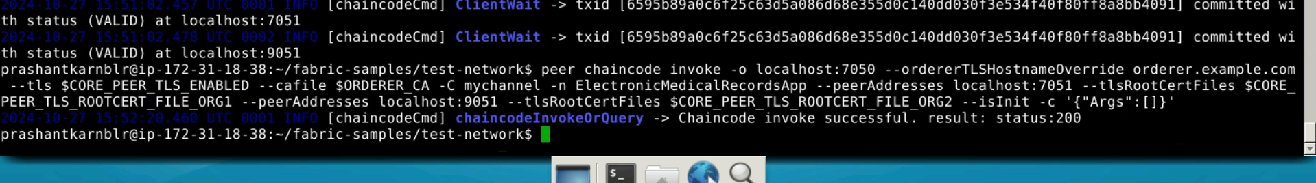

## Created patient

### Method name : createMedicalRecord

### Arguments : String patientId, String name, String diagnosis,String treatment, String dateofVisit

### Command:

peer chaincode invoke -o localhost:7050 --ordererTLSHostnameOverride orderer.example.com --tls $CORE_PEER_TLS_ENABLED --cafile $ORDERER_CA -C mychannel -n ElectronicMedicalRecordsApp --peerAddresses localhost:7051 --tlsRootCertFiles $CORE_PEER_TLS_ROOTCERT_FILE_ORG1 --peerAddresses localhost:9051 --tlsRootCertFiles $CORE_PEER_TLS_ROOTCERT_FILE_ORG2 -c '{"Args":["createMedicalRecord", "100", "John","Fever","Take Rest", "2024-10-27"]}'

### Result:

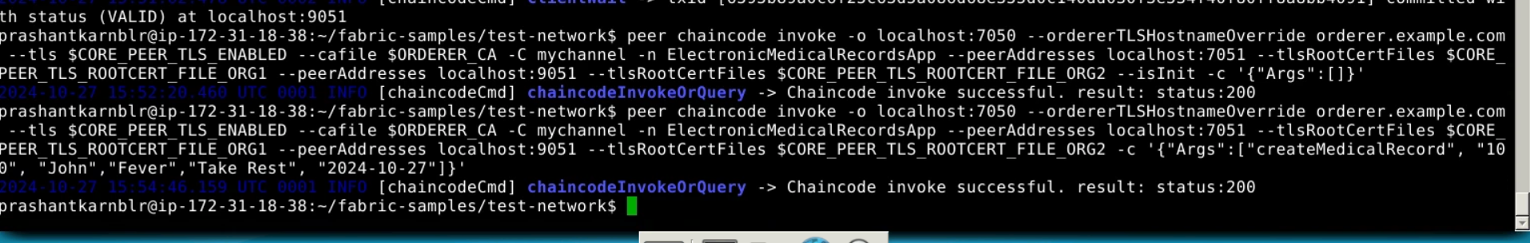

## View patient record

### Method name: viewMedicalRecord

### Arguments: String patientId

### Command:

peer chaincode invoke -o localhost:7050 --ordererTLSHostnameOverride orderer.example.com --tls $CORE_PEER_TLS_ENABLED --cafile $ORDERER_CA -C mychannel -n ElectronicMedicalRecordsApp --peerAddresses localhost:7051 --tlsRootCertFiles $CORE_PEER_TLS_ROOTCERT_FILE_ORG1 --peerAddresses localhost:9051 --tlsRootCertFiles $CORE_PEER_TLS_ROOTCERT_FILE_ORG2 -c '{"Args":["viewMedicalRecord", "100"]}'

### Result



### Not exist patient

peer chaincode invoke -o localhost:7050 --ordererTLSHostnameOverride orderer.example.com --tls $CORE_PEER_TLS_ENABLED --cafile $ORDERER_CA -C mychannel -n ElectronicMedicalRecordsApp --peerAddresses localhost:7051 --tlsRootCertFiles $CORE_PEER_TLS_ROOTCERT_FILE_ORG1 --peerAddresses localhost:9051 --tlsRootCertFiles $CORE_PEER_TLS_ROOTCERT_FILE_ORG2 -c '{"Args":["viewMedicalRecord", "404"]}'



### Same patient creation

peer chaincode invoke -o localhost:7050 --ordererTLSHostnameOverride orderer.example.com --tls $CORE_PEER_TLS_ENABLED --cafile $ORDERER_CA -C mychannel -n ElectronicMedicalRecordsApp --peerAddresses localhost:7051 --tlsRootCertFiles $CORE_PEER_TLS_ROOTCERT_FILE_ORG1 --peerAddresses localhost:9051 --tlsRootCertFiles $CORE_PEER_TLS_ROOTCERT_FILE_ORG2 -c '{"Args":["createMedicalRecord", "100", "John","Fever","Take Rest", "2024-10-27"]}'

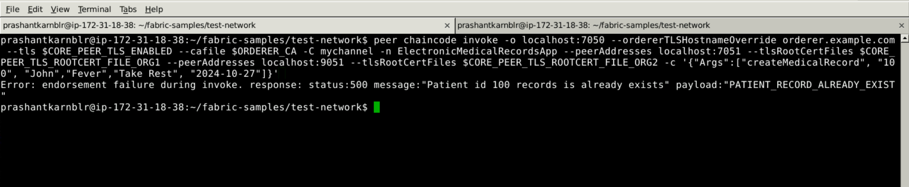

## Update record

### Method name: updateMedicalRecord

### Arguments : String patientId, String diagnosis, String treatment,String dateOfVisit

### Command:

peer chaincode invoke -o localhost:7050 --ordererTLSHostnameOverride orderer.example.com --tls $CORE_PEER_TLS_ENABLED --cafile $ORDERER_CA -C mychannel -n ElectronicMedicalRecordsApp --peerAddresses localhost:7051 --tlsRootCertFiles $CORE_PEER_TLS_ROOTCERT_FILE_ORG1 --peerAddresses localhost:9051 --tlsRootCertFiles $CORE_PEER_TLS_ROOTCERT_FILE_ORG2 -c '{"Args":["updateMedicalRecord", "100", "John","Dengue","Paracitamol", "2024-10-28"]}'

### Result:

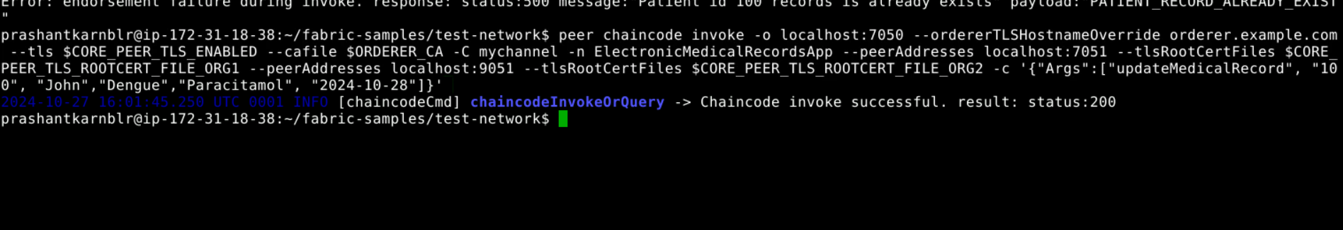

### Query updated details:

peer chaincode invoke -o localhost:7050 --ordererTLSHostnameOverride orderer.example.com --tls $CORE_PEER_TLS_ENABLED --cafile $ORDERER_CA -C mychannel -n ElectronicMedicalRecordsApp --peerAddresses localhost:7051 --tlsRootCertFiles $CORE_PEER_TLS_ROOTCERT_FILE_ORG1 --peerAddresses localhost:9051 --tlsRootCertFiles $CORE_PEER_TLS_ROOTCERT_FILE_ORG2 -c '{"Args":["viewMedicalRecord", "100"]}'

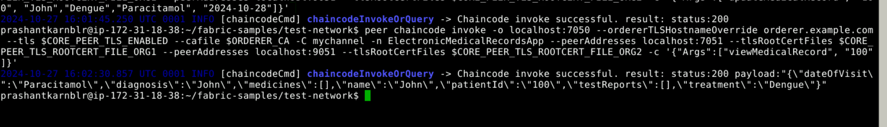

## Create reports:

### Method name: addTestReport

Arguments: String patientId, String reportId, String reportName, String description, String reportDate, String resportIssuer

### Command:

peer chaincode invoke -o localhost:7050 --ordererTLSHostnameOverride orderer.example.com --tls $CORE_PEER_TLS_ENABLED --cafile $ORDERER_CA -C mychannel -n ElectronicMedicalRecordsApp --peerAddresses localhost:7051 --tlsRootCertFiles $CORE_PEER_TLS_ROOTCERT_FILE_ORG1 --peerAddresses localhost:9051 --tlsRootCertFiles $CORE_PEER_TLS_ROOTCERT_FILE_ORG2 -c '{"Args":["addTestReport", "100", "1001","RBC Test","test the red blood cells", "2024-10-27", "Dr Tom"]}'

### Result:

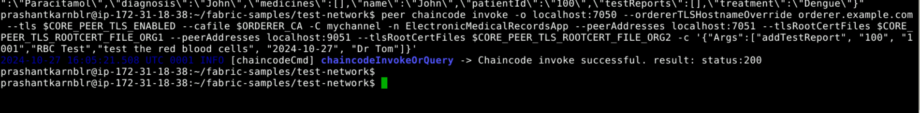

### Query reports:

peer chaincode invoke -o localhost:7050 --ordererTLSHostnameOverride orderer.example.com --tls $CORE_PEER_TLS_ENABLED --cafile $ORDERER_CA -C mychannel -n ElectronicMedicalRecordsApp --peerAddresses localhost:7051 --tlsRootCertFiles $CORE_PEER_TLS_ROOTCERT_FILE_ORG1 --peerAddresses localhost:9051 --tlsRootCertFiles $CORE_PEER_TLS_ROOTCERT_FILE_ORG2 -c '{"Args":["viewTestReports", "100"]}'

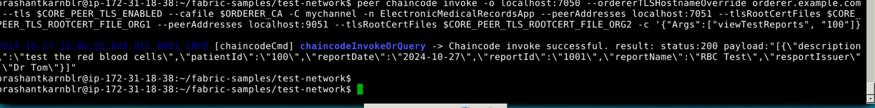

### Create same report:

peer chaincode invoke -o localhost:7050 --ordererTLSHostnameOverride orderer.example.com --tls $CORE_PEER_TLS_ENABLED --cafile $ORDERER_CA -C mychannel -n ElectronicMedicalRecordsApp --peerAddresses localhost:7051 --tlsRootCertFiles $CORE_PEER_TLS_ROOTCERT_FILE_ORG1 --peerAddresses localhost:9051 --tlsRootCertFiles $CORE_PEER_TLS_ROOTCERT_FILE_ORG2 -c '{"Args":["addTestReport", "100", "1001","RBC Test","test the red blood cells", "2024-10-27", "Dr Tom"]}'



### Create another report:

peer chaincode invoke -o localhost:7050 --ordererTLSHostnameOverride orderer.example.com --tls $CORE_PEER_TLS_ENABLED --cafile $ORDERER_CA -C mychannel -n ElectronicMedicalRecordsApp --peerAddresses localhost:7051 --tlsRootCertFiles $CORE_PEER_TLS_ROOTCERT_FILE_ORG1 --peerAddresses localhost:9051 --tlsRootCertFiles $CORE_PEER_TLS_ROOTCERT_FILE_ORG2 -c '{"Args":["addTestReport", "100", "2001","CBC test","test the heart ", "2024-11-27", "Dr Alis"]}'

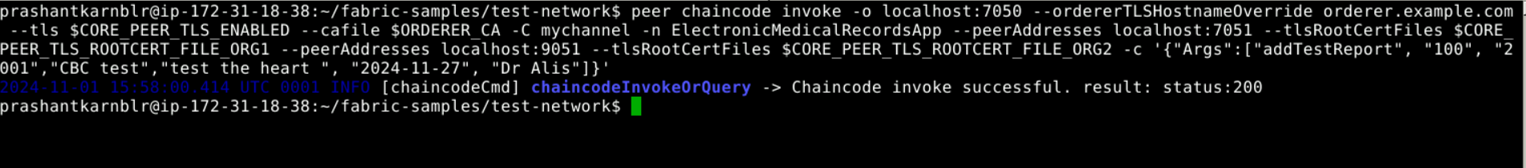

### Query test report:

peer chaincode invoke -o localhost:7050 --ordererTLSHostnameOverride orderer.example.com --tls $CORE_PEER_TLS_ENABLED --cafile $ORDERER_CA -C mychannel -n ElectronicMedicalRecordsApp --peerAddresses localhost:7051 --tlsRootCertFiles $CORE_PEER_TLS_ROOTCERT_FILE_ORG1 --peerAddresses localhost:9051 --tlsRootCertFiles $CORE_PEER_TLS_ROOTCERT_FILE_ORG2 -c '{"Args":["viewTestReports", "100"]}'

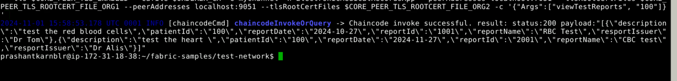

## Update test report

### Method name: updateTestReport

### Argument: String patientId, String reportId, String reportName, String description, String reportDate, String resportIssuer

### Command:

peer chaincode invoke -o localhost:7050 --ordererTLSHostnameOverride orderer.example.com --tls $CORE_PEER_TLS_ENABLED --cafile $ORDERER_CA -C mychannel -n ElectronicMedicalRecordsApp --peerAddresses localhost:7051 --tlsRootCertFiles $CORE_PEER_TLS_ROOTCERT_FILE_ORG1 --peerAddresses localhost:9051 --tlsRootCertFiles $CORE_PEER_TLS_ROOTCERT_FILE_ORG2 -c '{"Args":["updateTestReport", "100", "2001", "CBC test_updated", "Dr Alis updated", "2024-10-27", "Dr Tom"]}'

### Result:

query test report after update

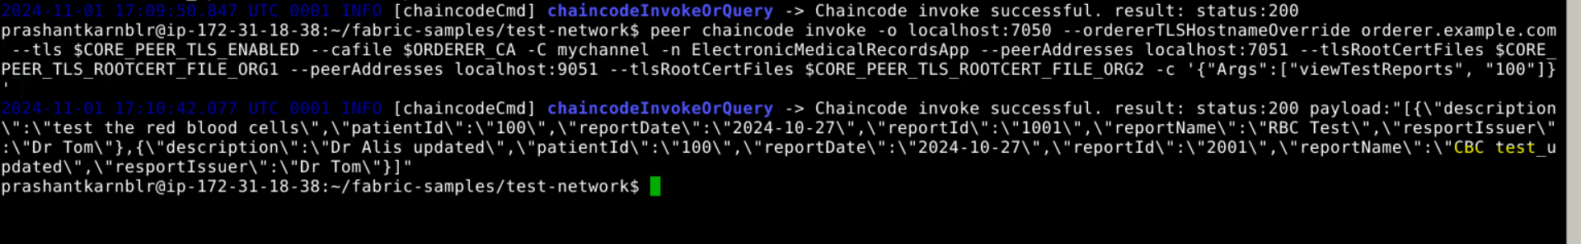

Trying to update the test report for patient which doesn’t exist:

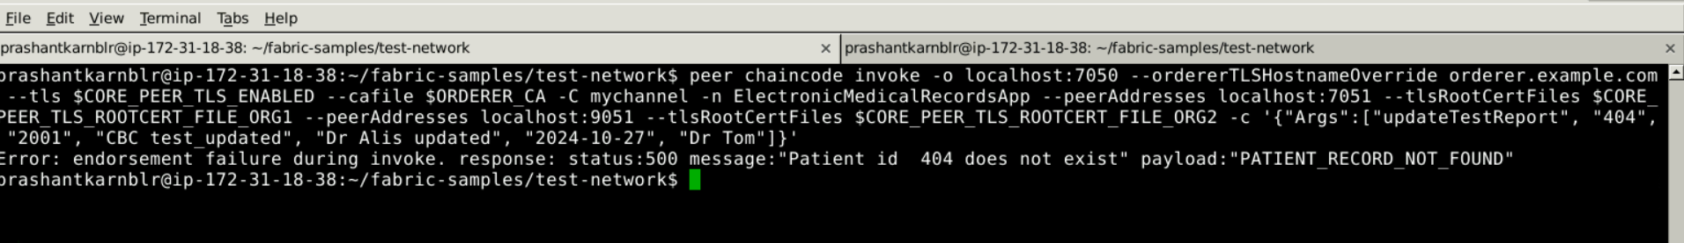

Tyring to update test report which doesn’t exist for patient

peer chaincode invoke -o localhost:7050 --ordererTLSHostnameOverride orderer.example.com --tls $CORE_PEER_TLS_ENABLED --cafile $ORDERER_CA -C mychannel -n ElectronicMedicalRecordsApp --peerAddresses localhost:7051 --tlsRootCertFiles $CORE_PEER_TLS_ROOTCERT_FILE_ORG1 --peerAddresses localhost:9051 --tlsRootCertFiles $CORE_PEER_TLS_ROOTCERT_FILE_ORG2 -c '{"Args":["updateTestReport", "100", "2404", "CBC test_updated", "Dr Alis updated", "2024-10-27", "Dr Tom"]}'

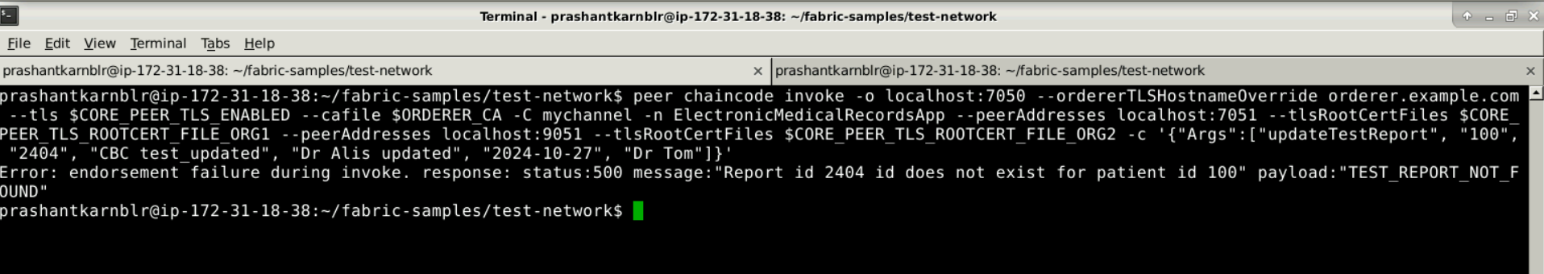

## Add medicine:

### Method name: addMedicine

### Arguments: String patientId, String medicineName, String medicineExpiry, String medicineTakenDate

### Command:

peer chaincode invoke -o localhost:7050 --ordererTLSHostnameOverride orderer.example.com --tls $CORE_PEER_TLS_ENABLED --cafile $ORDERER_CA -C mychannel -n ElectronicMedicalRecordsApp --peerAddresses localhost:7051 --tlsRootCertFiles $CORE_PEER_TLS_ROOTCERT_FILE_ORG1 --peerAddresses localhost:9051 --tlsRootCertFiles $CORE_PEER_TLS_ROOTCERT_FILE_ORG2 -c '{"Args":["addMedicine", "100","Paracitamol","2025-01-15", "2024-11-01"]}'

### Result:

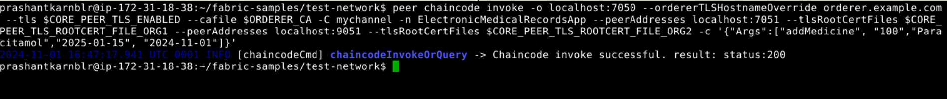

### Add more medicine:

peer chaincode invoke -o localhost:7050 --ordererTLSHostnameOverride orderer.example.com --tls $CORE_PEER_TLS_ENABLED --cafile $ORDERER_CA -C mychannel -n ElectronicMedicalRecordsApp --peerAddresses localhost:7051 --tlsRootCertFiles $CORE_PEER_TLS_ROOTCERT_FILE_ORG1 --peerAddresses localhost:9051 --tlsRootCertFiles $CORE_PEER_TLS_ROOTCERT_FILE_ORG2 -c '{"Args":["addMedicine", "100","Paracitamol","2025-01-15", "2024-11-02"]}'



## Query medicine taken on particular day:

### Method name: viewMedicineTakenOnParticularDate

### Arguments: String patientId, String date

### Command:

peer chaincode invoke -o localhost:7050 --ordererTLSHostnameOverride orderer.example.com --tls $CORE_PEER_TLS_ENABLED --cafile $ORDERER_CA -C mychannel -n ElectronicMedicalRecordsApp --peerAddresses localhost:7051 --tlsRootCertFiles $CORE_PEER_TLS_ROOTCERT_FILE_ORG1 --peerAddresses localhost:9051 --tlsRootCertFiles $CORE_PEER_TLS_ROOTCERT_FILE_ORG2 -c '{"Args":["viewMedicineTakenOnParticularDate", "100","2024-11-01"]}'

### Result:

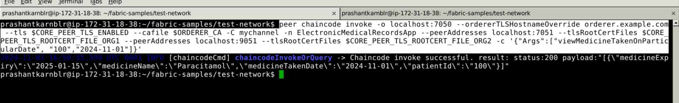

Adding more medicine:

peer chaincode invoke -o localhost:7050 --ordererTLSHostnameOverride orderer.example.com --tls $CORE_PEER_TLS_ENABLED --cafile $ORDERER_CA -C mychannel -n ElectronicMedicalRecordsApp --peerAddresses localhost:7051 --tlsRootCertFiles $CORE_PEER_TLS_ROOTCERT_FILE_ORG1 --peerAddresses localhost:9051 --tlsRootCertFiles $CORE_PEER_TLS_ROOTCERT_FILE_ORG2 -c '{"Args":["addMedicine", "100","irontablet","2025-01-15", "2024-11-02"]}'

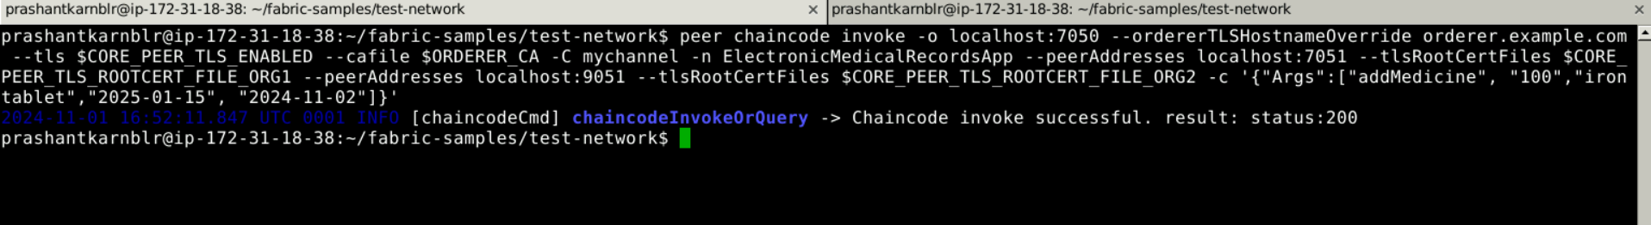

## Query medicine taken between days

### Method name: viewMedicineTakenOnStartAndEndDate

### Arguments: String patientId, String startDate, String endDate

### Command:

peer chaincode invoke -o localhost:7050 --ordererTLSHostnameOverride orderer.example.com --tls $CORE_PEER_TLS_ENABLED --cafile $ORDERER_CA -C mychannel -n ElectronicMedicalRecordsApp --peerAddresses localhost:7051 --tlsRootCertFiles $CORE_PEER_TLS_ROOTCERT_FILE_ORG1 --peerAddresses localhost:9051 --tlsRootCertFiles $CORE_PEER_TLS_ROOTCERT_FILE_ORG2 -c '{"Args":["viewMedicineTakenOnStartAndEndDate", "100","2024-11-01", "2024-11-03"]}'

### Result:

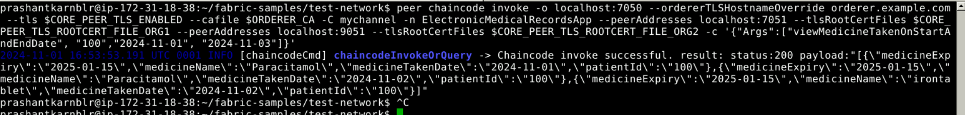

## Get all medicine:

### Method name: getAllMedicine

### Arguments: String patientId

### Command:

peer chaincode invoke -o localhost:7050 --ordererTLSHostnameOverride orderer.example.com --tls $CORE_PEER_TLS_ENABLED --cafile $ORDERER_CA -C mychannel -n ElectronicMedicalRecordsApp --peerAddresses localhost:7051 --tlsRootCertFiles $CORE_PEER_TLS_ROOTCERT_FILE_ORG1 --peerAddresses localhost:9051 --tlsRootCertFiles $CORE_PEER_TLS_ROOTCERT_FILE_ORG2 -c '{"Args":["getAllMedicine", "100"]}'

### Result:

